**Environmental Justice Demographic Profile  
Southwest Washington Regional Transportation Council**

**Published: January 2024**

**Clark County**

**Skamania County**

**Klickitat County**

**City of Vancouver**

**City of Camas**

**City of Washougal**

**City of Battle Ground**

**City of Ridgefield**

**City of La Center**

**Town of Yacolt**

**City of Stevenson**

**City of North Bonneville**

**City of White Salmon**

**City of Bingen**

**City of Goldendale**

**C-TRAN**

**Washington DOT**

**Port of Vancouver**

**Port of Camas-Washougal**

**Port of Ridgefield**

**Port of Skamania County**

**Port of Klickitat**

**Metro**

**Oregon DOT**

**14th Legislative District**

**17th Legislative District**

**18th Legislative District**

**20th Legislative District**

**49th Legislative District**



**Southwest Washington   
Regional Transportation Council**

|  |  |
| --- | --- |
| Street Address | Mailing Address |
| **1300 Franklin Street Vancouver, WA 98660** | **P.O. Box 1366 Vancouver, WA 98666-1366** |
|  |  |
| **Phone: 564-397-6067** |  |

**http://www.rtc.wa.gov**

RTC Respects Civil Rights:

RTC operates its programs without regard to race, color, national origin, religion, sex, sexual orientation, marital status, age or disability in accordance with applicable laws, including Title VI of the Civil Rights Act of 1964 and RCW 49.60. To request additional information on RTC’s Title VI nondiscrimination requirements, or if any person believes they have been aggrieved by an unlawful discriminatory practice under Title VI or other applicable law and would like to file a complaint, contact us at 564-397-6067 TTY 711 or email info@rtc.wa.gov. Persons who do not speak or read English well may request language assistance, oral interpretation and/or written translation, at no cost. Contact RTC at 564-397-6067 TTY 711 or email [info@rtc.wa.gov](mailto:info@rtc.wa.gov).

RTC Respeta los Derechos Civiles.

RTC opera sus programas independientemente de la raza, color, origen nacional, religión, sexo, orientación sexual, estado civil, edad o discapacidad de conformidad con las leyes aplicables, incluyendo el Título VI de la Ley de Derechos Civiles de 1964 y RCW 49.60. Para solicitar información adicional sobre los requisitos de no discriminación del Título VI de RTC, o si alguna persona cree que ha sido perjudicada por una práctica discriminatoria ilegal bajo el Título VI u otra ley aplicable y le gustaría presentar una queja, comuníquese con nosotros en el 564.397.6067 (TTY 711) o por correo electrónico info@rtc.wa.gov. Las personas que no hablan o leen Inglés bien pueden solicitar asistencia con el idioma, la interpretación oral y/o la traducción escrita, sin costo alguno. Comuníquese con RTC en el 564-397-6067 (TTY 711) o por correo electrónico [info@rtc.wa.gov](mailto:info@rtc.wa.gov).

RTC уважает гражданские права.

Региональный совет Юго-Западного Вашингтона по транспортному обслуживанию (RTC) в рамках своих программ не проявляет дискриминации по признаку расы, цвета кожи, национального происхождения, религии, пола, сексуальной ориентации, семейного положения, возраста или инвалидности в соответствии с применимым законодательством, включая раздел VI Закона «О гражданских правах» 1964 года и раздел 49.60 Свода пересмотренных законов штата Вашингтон. Чтобы получить дополнительную информацию о запрете дискриминации Региональным советом Юго-Западного Вашингтона по транспортному обслуживанию согласно разделу VI или если кто-то считает, что пострадал от дискриминации, оговоренной разделом VI или прочими законами, и желает подать жалобу, свяжитесь с нами по номеру 564.397.6067 (телетайп для слабослышащих 711) или по электронной почте info@rtc.wa.gov. Лица, не говорящие или не читающие на английском, могут запросить бесплатную услугу устного и/или письменного перевода. Свяжитесь с RTC по номеру 564-397-6067 (TTY 711) или по электронной почте [info@rtc.wa.gov](mailto:info@rtc.wa.gov).

Americans with Disabilities Act (ADA) Information

Individuals requiring reasonable accommodations may request written materials in alternate formats, sign language interpreters, physical accessibility accommodations, or other reasonable accommodations by contacting the ADA Coordinator, Jennifer Campos, at 564-397-5213 TTY 711, with two weeks' advance notice.

Las personas que requieran adaptaciones razonables pueden solicitar materiales escritos en formatos alternos, intérpretes de lenguaje de señas, adaptaciones de accesibilidad física, u otras adaptaciones razonables poniéndose en contacto con el Coordinador de ADA, Jennifer Campos, al 546-397-5213 o TTY 711, avisando con dos semanas de antelación.

Лица, которым требуются приемлемые обеспечения, могут запросить письменные материалы в альтернативных форматах, сурдопереводчиков, приспособления для физической доступности или другие приемлемые обеспечения, связавшись с координатором ADA Jennifer Campos по телефону 546-397-5213 или TTY 711 с предварительным уведомлением за две недели.

Table of Contents

Introduction 11

Definitions 12

People of Color 12

People with Lower Incomes 13

Other Title VI Protected Populations 13

Objectives 13

Census Data and GIS 14

Regional Profile Data Tables 14

Observations 14

Map Profiles 18

Equity Focus Areas 22

Data Notes 24

List of Tables and Maps

Figure 1 - RTC Planning Area 12

Table 1 - Population by Race and Hispanic/Latino Origin - 2020 15

Table 2 - People with Lower Incomes Statistics: 2020 15

Table 3 - People with Lower Incomes by Race and Hispanic/Latino Origin, 2020 S 16

Table 4 - Median Household Income by Race and Hispanic/Latino Origin, 2022 16

Table 5 - Population Age 65 and Over, 2020 17

Table 6 - People with Disabilities, 2020 17

Table 7 - Households with No Vehicle, 2020 17

Table 8 - Language Spoken at Home by Ability to Speak English, 2020 18

Table 9 - Equity Focus Area Thresholds 22

Map 1: People of Color, 2020 19

Map 2: People with Lower Incomes, 2020 20

Map 3: Limited English Proficiency, 2020 21

Map 4: Equity Focus Areas, 2020 23

# Environmental Justice Demographic Profile: Clark County

## Introduction

Since the mid-1990s, a renewed emphasis on environmental justice has become an integral part of the transportation planning process for urban regions in the United States. The concept of “environmental justice” is derived from Title VI of the Civil Rights Act of 1964[1] and other civil rights statutes and was first put forth as a national policy goal by presidential Executive Order 12898, issued in 1994, which directs “each federal agency to make achieving environmental justice part of its mission by identifying and addressing, as appropriate, disproportionately high and adverse human health or environmental effects of its programs, policies, and activities on minority populations and lower-income populations.”2

The U.S. Department of Transportation (DOT) responded to the directive with its DOT Order to Address Environmental Justice in Minority Populations and Lower-Income Populations in 19973. The order laid out the following environmental justice principles to be integrated into federal transportation programs, policies, and activities:

1. To avoid, minimize, or mitigate disproportionately high and adverse human health and environmental effects, including social and economic effects, on minority and lower-income populations.
2. To ensure the full and fair participation by all potentially affected communities in the transportation decision-making process.
3. To prevent the denial of, reduction in, or significant delay in the receipt of benefits by people of color and people with lower incomes.

The DOT has issued an updated internal Order in May 2012. DOT Order 5610(a) continues to be a key component of the Department’s strategy to promote the principles of environmental justice in all Departmental programs, policies, and activities.

With this guidance the Federal Highway Administration (FHWA) and Federal Transit Administration (FTA) renewed their commitments to ensure that environmental justice is carried out in the programs and strategies they fund, including the activities of metropolitan planning organizations (MPOs).4 The FHWA has specifically directed MPOs to:

1. Enhance their analytical capabilities to ensure that their long-range transportation plan and their transportation improvement program comply with Title VI.
2. Identify residential, employment, and transportation patterns of people with lower incomes and people of color so that their needs can be identified and addressed and the benefits and burdens of transportation investments can be fairly distributed.
3. Evaluate and, where necessary, improve their public involvement processes to eliminate participation barriers and engage people of color and people with lower incomes in transportation decision-making.

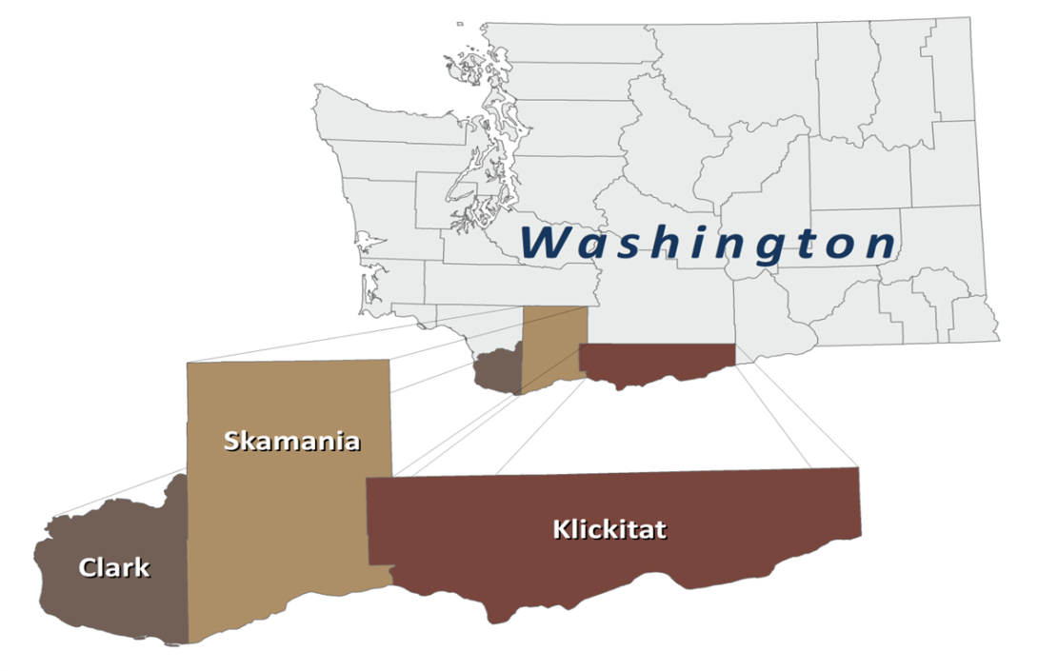The Southwest Washington Regional Transportation Council (RTC) is the federally designated MPO, as well as the state designated regional transportation planning organization (RTPO), for Clark County, Washington. Under these mandates RTC is responsible for developing and regularly updating the region’s long-range transportation plan, as well as distributing federal transportation funds to local projects through its transportation improvement program. This document contains a baseline profile of key demographic data describing the Clark County region and identifies population groups and communities to be considered in environmental justice analyses and activities.

Figure 1 - RTC Planning Area

## Definitions

Executive Order 12898 and the DOT, FHWA, and FTA orders on environmental justice address persons belonging to any of the following groups:

### People of Color

1. Black - a person having origins in any of the Black racial groups of Africa.
2. American Indian and Alaskan Native - a person having origins in any of the original people of North America and who maintains cultural identification through tribal affiliation or community recognition.
3. Asian - a person having origins in any of the original peoples of the Far East, Southeast Asia, or the Indian subcontinent.
4. Native Hawaiian and Other Pacific Islander – a person having origins in any of the original peoples of Hawaii, Guam, Samoa, or other Pacific Islands.
5. Hispanic - a person of Mexican, Puerto Rican, Cuban, Central or South American, or other Spanish culture or origin, regardless of race.

### People with Lower Incomes

1. A person whose household income (or in the case of a community or group, whose median household income) is at or below the U.S. Department of Health and Human Services (HHS) poverty guidelines. States and localities may, however, adopt a higher threshold for lower-income as long as the higher threshold is not selectively implemented and is inclusive of all persons at or below the HHS poverty guidelines.

### Other Title VI Protected Populations

1. While the various orders on environmental justice require consideration of only people of color and people with lower incomes as defined above, discussions of other populations protected by Title VI and related nondiscrimination statutes—such as the elderly, those with disabilities, etc.—are encouraged in addressing environmental justice and Title VI in federally sponsored transportation programs, policies, and activities and are, therefore, included in this profile.

___________________________________  
4 FHWA Actions to Address Environmental Justice in Minority Populations and Lower-Income Populations, December 1998; and FHWA and FTA Memorandum Implementing Title VI Requirements in Metropolitan and Statewide Planning, October 1999

1. Limited English Proficiency (LEP) - Executive Order 13166: Improving Access to Service for Persons with Limited English Proficiency, clarified the Title VI of the Civil Rights Act of 1964 with regard to accessibility of federal programs and services to persons who are not proficient in the English language. This executive order stated that individuals who do not speak, read, write, or understand English well are entitled to language assistance under Title VI of the Civil Rights Act of 1964 with respect to a particular type of service, benefit, or encounter. LEP populations are included in this profile.

## Objectives

RTC set out to meet two primary objectives in preparing this environmental justice demographic profile:

1. Compile key demographic data on people of color and people with lower incomes in the Clark County region, as well as other populations of interest, for environmental justice consideration in conducting regional transportation planning and program activities and public outreach.
2. Identify the locations of communities within the region with significant people of color and people with lower incomes in order to facilitate and enhance environmental justice analyses and activities.

## Census Data and GIS

RTC relied upon data products from the 2016-2020 American Community Survey 5-Year Estimates and 2020 Decennial Census to provide the most up-to-date demographic data for Clark County, WA. Geographic information systems (GIS) applications were also utilized to map graphic representations of the data. While data from the 2020 U.S. Census and American Community Survey is several years old, it continues to be the most comprehensive, reliable, and geographically detailed source of demographic information currently available.

## Regional Profile Data Tables

Drawing from the U.S. Census data, RTC compiled data tables of key demographic statistics on the region’s people of color and people with lower incomes and other populations and characteristics of interest for environmental justice consideration. The data tables report statistics for Clark County, Washington, the MPO boundary.

Table 1 – Population by Race and Hispanic/Latino Origin: 2020

Table 2 – People with Lower Incomes: 2020

Table 3 – People with Lower Incomes by Race and Hispanic/Latino Origin: 2020

Table 4 – Median Household Income by Race and Hispanic/Latino Origin: 2020

Table 5 – Population Age 65 and Over: 2020

Table 6 – People with Disabilities: 2020

Table 7 – Households with No Vehicle: 2020

Table 8 – Language Spoken at Home by Ability to Speak English: 2020

### Observations

Tables 1 and 2 provide essential statistics on the region’s people of color and people with lower incomes. People of color—or non-White persons, including White persons of Hispanic/Latino origin—comprised 18.1 percent of the region’s total population in 2020. Blacks/African Americans constitute 2.3 percent of the region’s total population; American Indians/Alaskan Natives, 1.0 percent; Asians/Pacific Islanders, 5.9 percent; and Hispanics/Latinos, 11.7 percent.

Table 1 - Population by Race and Hispanic/Latino Origin - 2020

Source: 2020 Decennial Census

|  |  |  |
| --- | --- | --- |
|  | Number | Percentage |
| White | 379,827 | 75.5% |
| Black or African American | 11,396 | 2.3% |
| American Indian and Alaska Native | 4,835 | 1.0% |
| Asian/Pacific Islander | 29,580 | 5.9% |
| Other race or two or more races | 31,417 | 6.2% |
| Hispanic or Latino (of any race) | 58,790 | 11.7% |
| Total People of Color (non-White including White/Hispanic | 91,110 | 18.1% |

In 2020 the regionwide *people with lower incomes* rate was 9.1 percent. Table 2 also reports statistics for the percentage of the region’s population below 150 percent and 200 percent of the federal poverty level in 2020. These statistics indicate that there are substantial numbers of families and individuals in the region whose incomes are above the federal poverty level but within a range that may still be considered lower income, particularly when taking into account the cost of living in the Vancouver/Portland metropolitan region. Federal poverty thresholds are not adjusted for regional, state, and local variations in the cost of living, which is presumably higher in the Vancouver/Portland metropolitan region relative to other areas of the United States on average because of higher local housing costs.

Table 2 - People with Lower Incomes Statistics: 2020

Source: 2016-2020 American Community Survey 5-year Estimates – Table C17002

|  |  |  |  |
| --- | --- | --- | --- |
| Population for whom lower income status is determined | Income | | |
| Below 100% poverty level | Below 150% poverty level | Below 200% poverty level |
| 477,065 | 43,190 | 72,700 | 109,368 |
| *100.0%* | *9.1%* | *15.2%* | *22.9%* |

Tables 3 and 4 illustrate the relationship between people of color and people with lower incomes. Population of people with lower incomes are higher and median household incomes are lower for people of color populations compared to the White population or total population overall

Table 3 - People with Lower Incomes by Race and Hispanic/Latino Origin, 2020  
 Source: 2016-2020 American Community Survey 5-year Estimates – Table S1703

|  |  |
| --- | --- |
| Race and Hispanic/Latino Origin | Percentage |
| White | 8.3% |
| Black or African American | 15.3% |
| American Indian and Alaska Native | 9.9% |
| Asian | 11.2% |
| Native Hawaiian and other Pacific Islander | 11.3% |
| Some Other Race | 13.6% |
| Two or More Races | 12.1% |
| White Alone, not Hispanic or Latino | 8.0% |
| Hispanic or Latino (of any race) | 13.1% |
| Total People of Color (non-White including White/Hispanic | 12.7% |

Table 4 - Median Household Income by Race and Hispanic/Latino Origin, 2022

Source: 2016-2020 American Community Survey 5-year Estimates – Table S19003

|  |  |
| --- | --- |
| Race and Hispanic/Latino Origin | Median Income |
| White | $61,954 |
| Black or African American | $42,788 |
| American Indian and Alaska Native | $50,500 |
| Asian | $70,577 |
| Native Hawaiian and other Pacific Islander | $51,466 |
| Some Other Race | $39,786 |
| Two or More Races | $55,363 |
| White Alone, not Hispanic or Latino | $62,593 |
| Hispanic or Latino (of any race) | $41,362 |
| All Households | $60,756 |

Tables 5 and 6 present demographic statistics, including people with lower incomes, for the region’s elderly and people with disabilities. People with disabilities are shown to have significantly higher rates of people with lower incomes than the total population overall, whereas people with lower incomes for the elderly population are lower.

Table 5 - Population Age 65 and Over, 2020

Source: 2016-2020 American Community Survey 5-year Estimates – Table S0103

|  |  |  |  |  |
| --- | --- | --- | --- | --- |
| Total Population | Age 65 and over | | | |
| Population Age 65 and over | | For whom lower income status is determined | |
| Number | Percent | Number of People | Lower Income Percentage |
| 481,950 | 74,453 | 1% | 5,533 | 7.5% |

Table 6 - People with Disabilities, 2020

Source: 2016-2020 American Community Survey 5-year Estimates – Tables S1810 and C18130

|  |  |  |  |  |
| --- | --- | --- | --- | --- |
| Total Population | With Disabilities | | | |
| People with Disabilities | Population for whom lower income status is determined | | |
| Total People with Disabilities | Number of People | Lower Income Percentage |
| 479,209 | 57,763 | 57,474 | 9,481 | 16.5% |

Table 7 shows that nearly 5% of households within Clark County do not have a vehicle available.

Table 7 - Households with No Vehicle, 2020

Source: 2016-2020 American Community Survey 5-year Estimates – Table B08201

|  |  |  |
| --- | --- | --- |
| Total Households | Households with no vehicles | Percent with no vehicles |
| 178,478 | 8,130 | 4.6% |

Finally, Table 8 presents Clark County statistics on persons with limited English proficiency and common languages other than English spoken. This information is intended to support the development of the public outreach and involvement component of the RTC’s environmental justice program.

Table 8 - Language Spoken at Home by Ability to Speak English, 2020

Source: 2016-2020 American Community Survey 5-year Estimates – Table C16001

|  |  |  |  |
| --- | --- | --- | --- |
|  |  | Number | Percentage |
| Speaks English Less Than "Very Well" | Spanish or Spanish Creole | 10,763 | 2.4% |
| Russian, Polish, or other Slavic | 6,820 | 1.5% |
| Vietnamese | 1,984 | 0.4% |
| Chinese | 1,805 | 0.4% |
| Other Languages1 | 5,275 | 1.2% |
| Total, All Languages | Speak English less than "very well" | 26.647 | 5.9% |
| Speak English "very well"2 | 426,051 | 94.1% |

1 Other languages excluding English only

2 “Speak English ‘very well’” includes “Speak only English”

## Map Profiles

In addition to compiling the regional profile data tables described above, RTC utilized its geographic information systems (GIS) applications to map the distributions of people of color and people with lower incomes across the region to identify geographic areas and communities with substantial people of color, people with lower incomes, and people with Limited English Proficiency in Clark County.

Map 1 – People of Color Population, Clark County: 2020

Map 2 – People with Lower Incomes, Clark County: 2020

Map 3 – Limited English Proficiency, Clark County: 2020

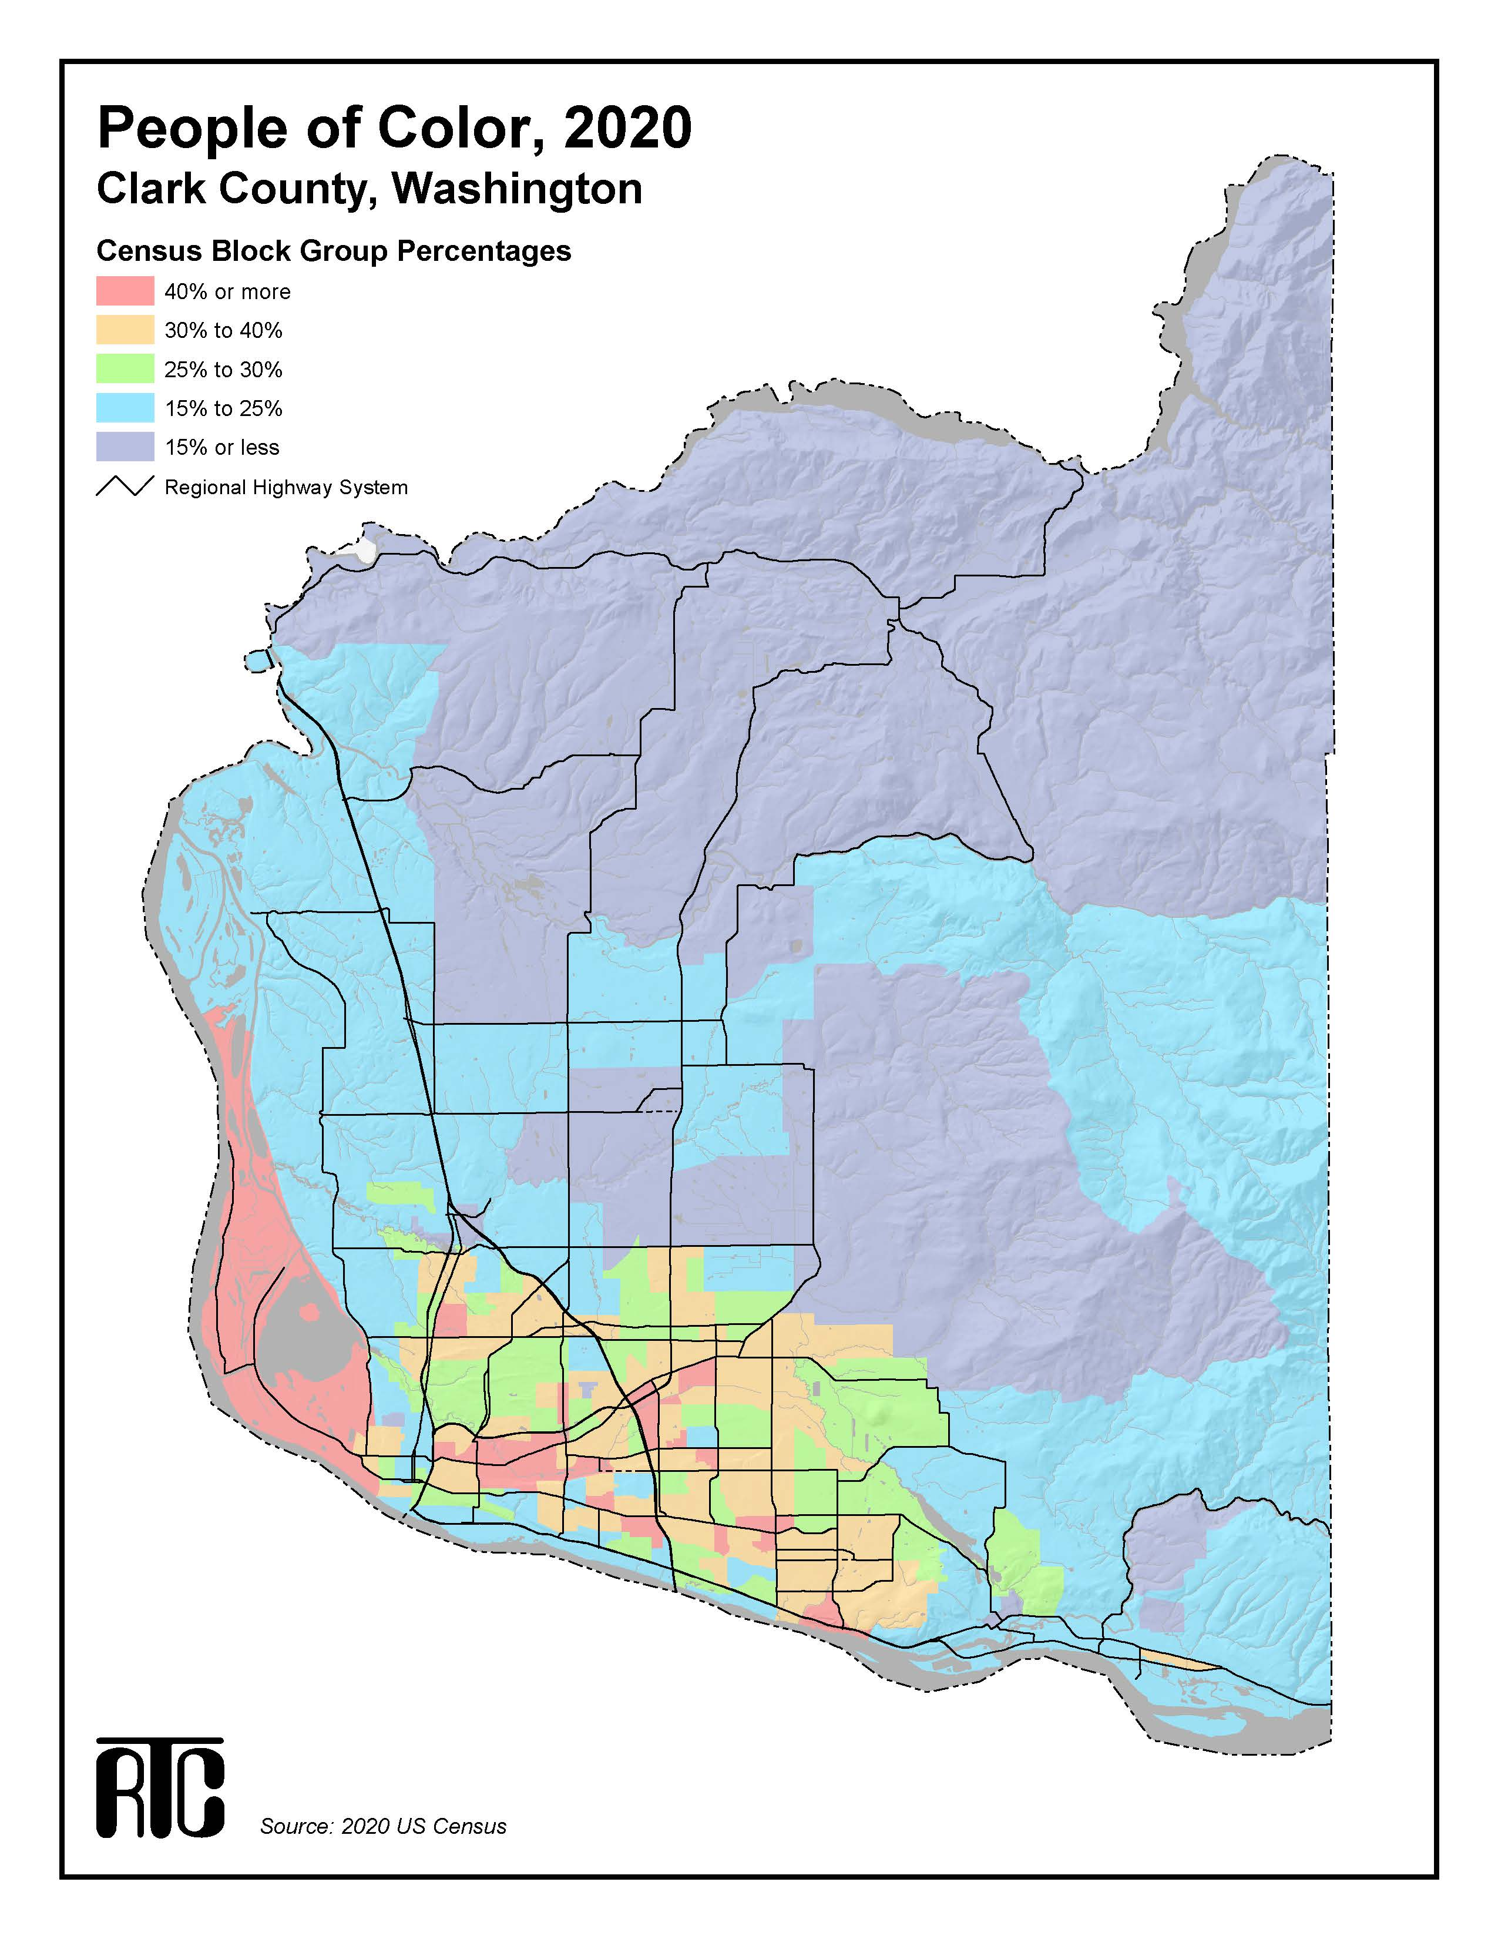Map 1: People of Color, 2020

Map 2: People with Lower Incomes, 2020

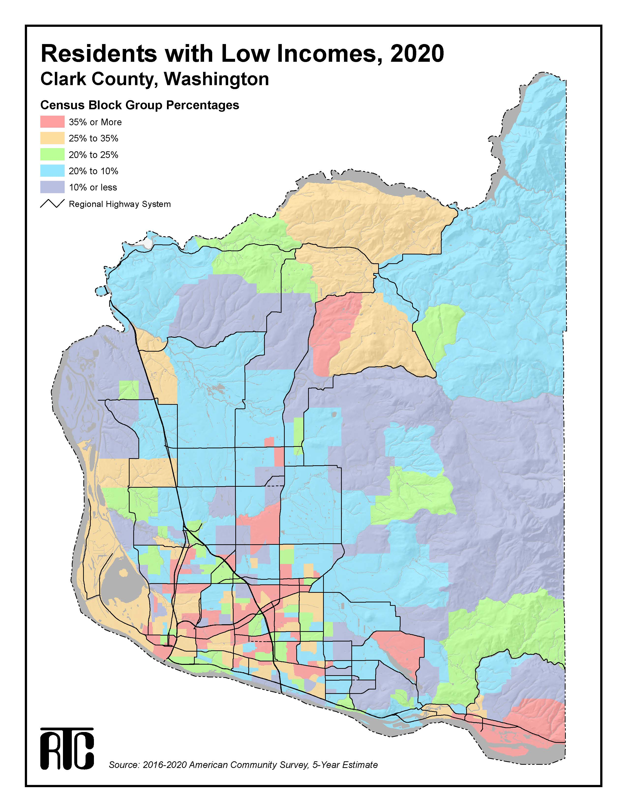

Map 3: Limited English Proficiency, 2020

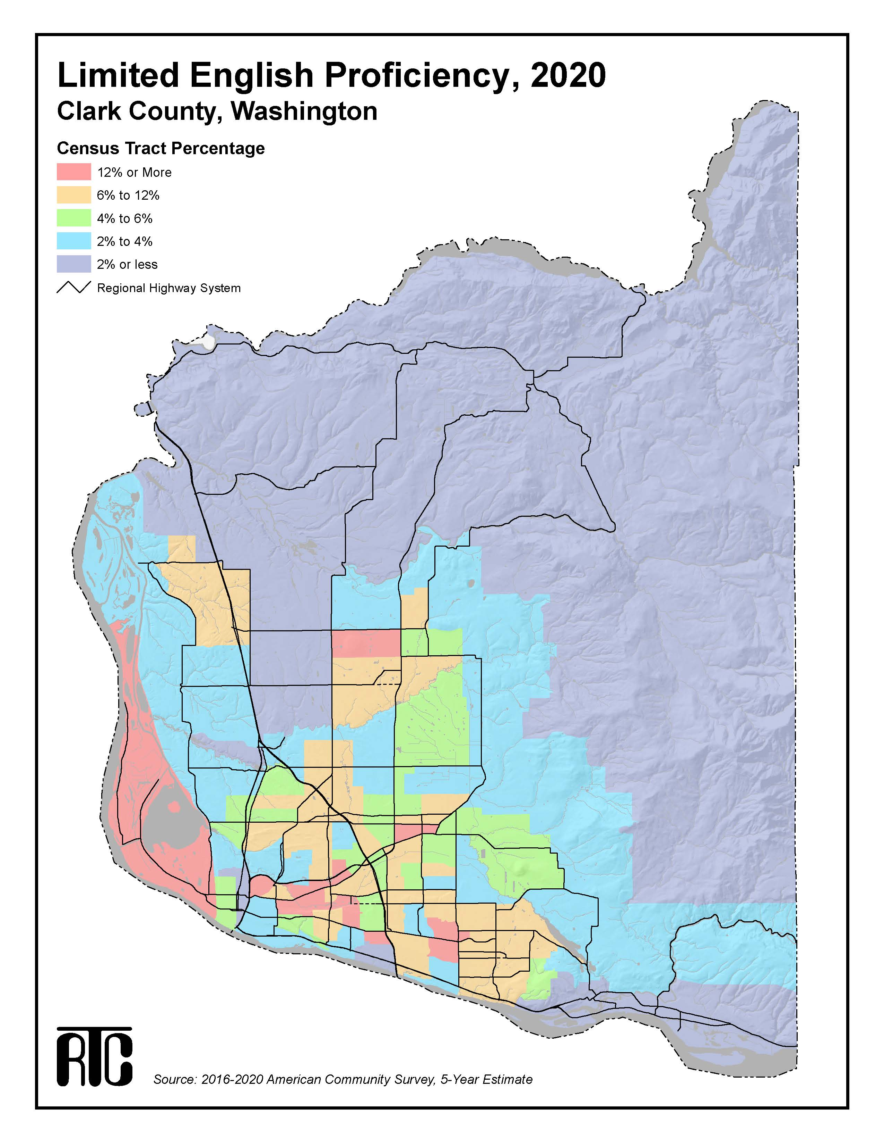

## Equity Focus Areas

This information was then used to map overlapping areas to identify the locations of communities within the region with significant people of color, people with lower incomes, and people with limited English proficiency to help facilitate and enhance RTC’s environmental justice analyses and activities.

Equity Focus Areas are census block groups or tracts with higher than the Clark County average concentrations and double the density for the following populations: of people of color (block group), people with low incomes (block group) and people with limited English proficiency (tract). Most of these areas also include higher than regional average concentrations of other marginalized communities, including youth, older adults and people living with disabilities. The threshold rates for each population are identified in the table below.

Table 9 - Equity Focus Area Thresholds

|  |  |  |  |
| --- | --- | --- | --- |
| Community | Definition | Geographic  Threshold | Data Source |
| People of Color | Persons who identify as Hispanic or Latino, Black or African American, American Indian and Alaska Native, Asian, Native Hawaiian and Other Pacific Islander, or Some Other Race. | The census block groups that are above the Clark County rate (27.1%) for people of color AND the census tract has twice (2x) the population density of the county (1.25 persons per acre). | 2020 U.S. Census |
| People with Lower Incomes | Persons with incomes less than 200% of the Federal Poverty Level. | The census block groups that are above the Clark County rate (22.9%) for people with lower incomes AND the census tract has twice (2x) the population density of the county (1.19 persons per acre). | American Community Survey, 2016-2020 |
| People with limited English proficiency | Persons 5 years and older who identify as unable “to speak English very well.” | The census tracts that are above the Clark County rate (5.89%) for people with limited English proficiency (all languages combined) AND the census tract has twice (2x) the population density of the county average (1.12 person per acre). | American Community Survey, 2016-2020 |

Map 4 illustrates the spatial distribution of people of color, people with lower incomes, and people with limited English proficiency in the Clark County region. The identified Equity Focus Areas contain about 58% of the region’s total population, 70% of the region’s people of color population, 72% of the region’s people with lower incomes population, and 78% of the region’s LEP population.

Map 4: Equity Focus Areas, 2020

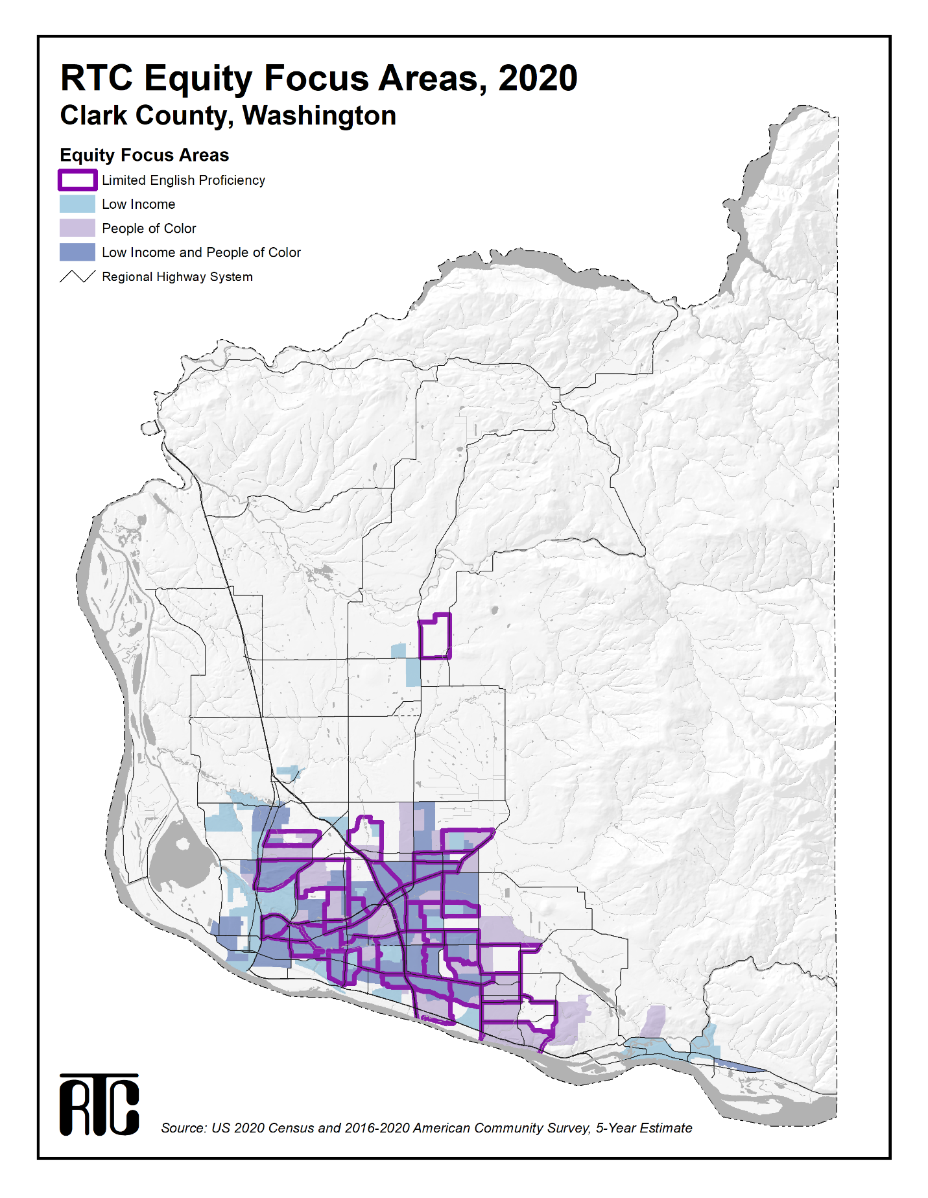

### Data Notes

Race – The federal race classification categories “Asian alone” and “Native Hawaiian and Other Pacific Islander alone” were combined in the regional profile data tables, where possible, as “Asian/Pacific Islander alone.” In the 2016-2020 American Community Survey 5-year Estimates, the “Some other race” category included all responses to the race question other than “White,” “Black or African American,” “American Indian and Alaskan Native,” “Asian,” or “Native Hawaiian and Other Pacific Islander.” Write-in responses such as multiracial, mixed, or interracial (where the multiple races were not identified) or a Hispanic/Latino group—such as Mexican, Puerto Rican, or Cuban—were included in the “Some other race” category. In the 2016-2020 American Community Survey 5-year Estimates, the “Two or more races” category included responses to the race question involving two or more combinations of “White,” “Black or African American,” “American Indian and Alaskan Native,” “Asian,” “Native Hawaiian and Other Pacific Islander,” and “Some other race,” including write-in responses.

Hispanic/Latino – 2016-2020 American Community Survey 5-year Estimates considered Hispanic/Latino origin as an ethnic characteristic separate from race. A person who identified their origin as Spanish, Hispanic, or Latino may be of any race, including White.

Total People of Color – The term “total people of color” represents the union between, not the sum of, people of color populations and the Hispanic/Latino population and includes White persons of Hispanic/Latino origin.

People with Lower Incomes – There are two slightly different versions of the federal poverty measure: poverty thresholds and poverty guidelines. The poverty thresholds are the original version of the federal poverty measure that was first developed by the Social Security Administration (SSA) and which has been updated each year by the Census Bureau. The poverty guidelines are a simplified version of the poverty thresholds, issued each year in the Federal Register by the Department of Health and Human Services (HHS). The 2020 poverty data reported in the regional profile tables and utilized in the GIS map profile of the region’s people with lower incomes were derived using the Census Bureau’s poverty thresholds.

People with Disabilities – In the 2016-2020 American Community Survey 5-year Estimates, disability was defined as:

1. The existence of the following long-lasting conditions:
   1. Sensory disability - blindness, deafness, or a severe vision or hearing impairment
   2. Physical disability - a condition that substantially limits one or more basic physical activities, such as walking, climbing stairs, reaching, lifting, or carrying; or
2. The existence of a physical, mental, or emotional condition lasting six (6) months or more that makes it difficult to perform the following activities:
   1. Mental disability - learning, remembering, or concentrating
   2. Self-care disability - dressing, bathing, or getting around inside the home
   3. Go outside home disability - going outside the home alone to shop or visit a doctor’s office
   4. Employment disability - working at a job or business

Individuals were classified as having a disability if they belonged to the civilian noninstitutionalized population and they were 5 years and over and had a sensory, physical, mental, or self-care disability; they were 16 years and over and had a *go outside home* disability; and/or they were 16 to 64 years old and had an employment disability.

Limited English Proficiency – In the 2016-2020 American Community Survey 5-year Estimates, the English proficiency question was asked of a sample of the population who reported that they spoke a language other than, or in addition to, English at home. Respondents were asked to rate their ability to speak English in one of the following categories: “Very well,” “Well,” “Not well,” or “Not at all.” RTC classified persons as being limited English proficient if they responded with any answer other than “Very well.” Persons who spoke only English at home were assumed to be English proficient. Language proficiency was tabulated for the population age 5 and over.

1. 1 “Title VI of the Civil Rights Act of 1964 states that “no person in the United States shall, on the ground of race, color, or national origin, be excluded from participation in, be denied the benefits of, or be subjected to discrimination under any program or activity receiving Federal financial assistance.”

   2 Executive Order 12898, Federal Actions to Address Environmental Justice in Minority Populations and Low-Income Populations, February 1994.

   3 DOT Order to Address Environmental Justice in Minority Populations and Low-Income Populations, April 1997.